# Media Analysis - ChatGPT AI grows more powerful as we become more predictable

## Short Summary

": "The article underscores ChatGPT's swift global adoption as an indicator of the emerging AI era, while acknowledging its lack of genuine intelligence and ethical challenges such as bias reinforcement, suppression of dissenting views, and limitations in balancing creativity with constraints."  
}

## Summary

1. **Rapid Adoption Rate**: The advent of ChatGPT, an AI large language model owned by OpenAI, has seen unprecedented speedy adoption with a million unique users within five days of its release.  
   
2. **AI in Emerging Markets**: Despite being in their infancy, platforms like ChatGPT are rapidly gaining popularity among companies and governments globally, particularly in emerging markets, signaling an eagerness for AI technology.  
  
3. **Limited AI Intelligence**: Unlike the human mind's capacity to develop language with minimal data from its environment, large language models such as ChatGPT analyze vast amounts of data to produce content based on guesses about trends in that data.  
   
4. **Predictable Human Behavior**: OpenAI's algorithm assumes human behavior is predictable by analyzing extensive datasets. This aligns with recent trends where internet usage and smartphone interaction shape our online behaviors, making them increasingly predictable.  
  
5. **AI Ability to Reason**: While AI tools can mimic some aspects of human reasoning, they lack the ability to truly reason or grasp complex, nuanced concepts that humans can effortlessly apply, as noted by linguist Noam Chomsky.  
  
6. **Ethical Concerns in AI Development**: The overzealous embrace of AI tools like ChatGPT raises ethical issues such as reinforcing ideologies and worldviews, potentially locking them in place without contestation or improvement. Microsoft's recent dismissal of its entire AI ethics team serves as a stark reminder of these concerns.  
  
7. **AI's Role vs. Human Intelligence**: Collaborative use of AI tools like ChatGPT can enhance human productivity and efficiency, but they cannot replace the unique capabilities of human intelligence. The iPhone demonstrated how technology facilitates communication without fundamentally altering work processes. Similarly, ChatGPT will not change the essence of work; it should be integrated in a thoughtful, incremental way rather than rushing to drastically overhaul working models.

## Question 1:

How do the media in this article frame the public discussion about ChatGPT? Are there certain **metaphors** that keep cropping up?

The media frames the public discussion about ChatGPT through two main metaphors: 1) 'AI growth curve', emphasizing the technology's rapid development like other technological advancements. 2) 'AI predictability', highlighting that ChatGPT operates based on patterns and predictions, contrasting human complexity in cognition.

## Question 2:

Which role does or might the Arabic World play in the development of Artificial Intelligence? Answer with 'Not mentioned' if not applicable.

Not mentioned

## Question 3:

Which use cases of Artificial Intelligence are helpful for the Arabic world based on this article?

The article primarily discusses ChatGPT, a large language model developed by OpenAI. Its rapid growth and impact on various industries suggest potential use cases like content creation for businesses and organizations in the Arabic context, such as producing articles, reports or social media posts that cater to the Arabic language.

## Question 4:

What is the final message of the article that the author wants to convey? Keep your answer short and precise!

The final message of the article emphasizes balanced integration of AI, appreciating its efficiency while recognizing the importance of preserving and evolving human intelligence. It calls for thoughtful approach considering ethical implications and limitations of current AI systems, advocating for collaboration rather than complete takeover by these tools.

## Sentiment

The sentiment is <3>

The article presents a balanced perspective on ChatGPT, discussing its rapid adoption, the limitations of AI in mimicking human intelligence, ethical concerns, and the potential for collaboration between humans and AI tools. The author highlights both the opportunities and challenges posed by AI, suggesting a cautious yet optimistic viewpoint.

## Entities

Https Microsoft Ethic Society Responsible Ai, White Paper Launch, Microsoft, New York Times, Openai Approach Chatgpt Notion Human Behavior Predictable Analyze Large, Chatgpt Ai, Serendipitously Stumble Book Know, Noam Chomsky, Miss Vital Point Human Development Impact Society Ethical Issue, Joseph Dana Predictable Ai Tool Lack Fundamental Ability

## Topic Clusters

### Cluster: AI Evolution and Development

AI growth, ChatGPT emergence

### Cluster: Future of Artificial Intelligence

AI-powered future, ChatGPT-4 potential

## Word Clouds

### Wordcloud of content

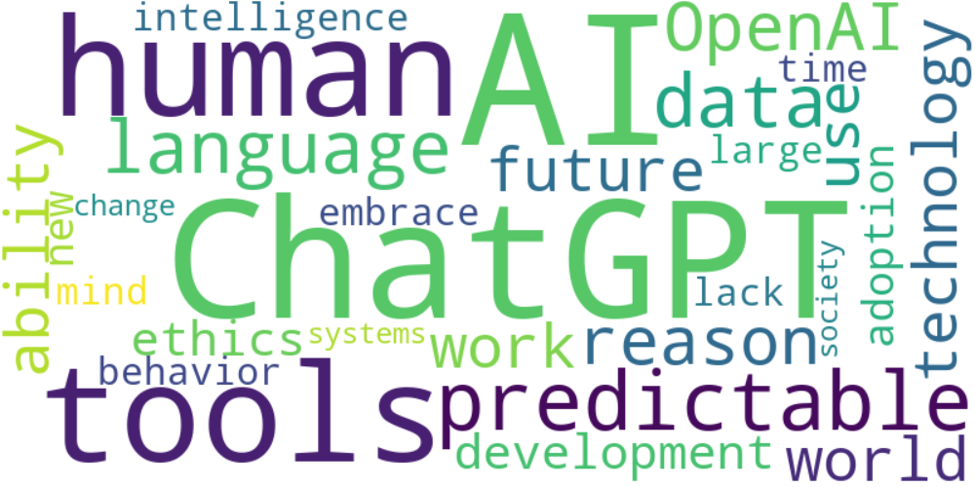

Top 10 words:

- AI: 15  
- ChatGPT: 12  
- tools: 8  
- human: 8  
- predictable: 6  
- language: 6  
- data: 6  
- OpenAI: 5  
- reason: 5  
- technology: 4

### Wordcloud of summary

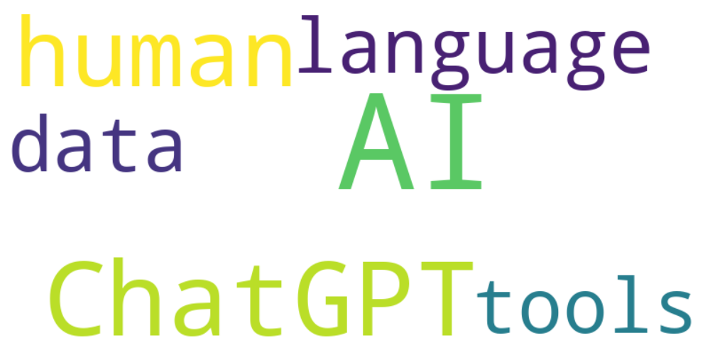

Top 10 words:

- AI: 11  
- ChatGPT: 6  
- human: 5  
- language: 3  
- like: 3  
- data: 3  
- tools: 3